OPSC6311 POE
Research document

Group participants:
ST10457568 [TINOTENDA MARUMAHOKO]
ST10454395 [CAMERON REECE JOHANNES]
ST10451742 [WASAMA MAKOLO]
ST10438423[LIAM FRANS]

1. Introduction
Personal budgeting applications are digital tools designed to help individuals manage their finances by tracking income, expenses, savings, and financial goals. These applications are widely used on smartphones, allowing users to monitor their spending habits and make informed financial decisions.
Effective financial management is important for achieving financial stability. Traditional budgeting methods, such as spreadsheets and manual record-keeping, can be time-consuming and difficult to maintain. Budgeting applications simplify this process by automatically organizing financial data and presenting it through user-friendly dashboards, charts, and reports. This enables users to better understand and manage their personal finances.
The purpose of this research is to examine and compare three Android budgeting applications: Mint, YNAB (You Need A Budget), and Wallet by BudgetBakers. The study evaluates their features, strengths, weaknesses, and innovative functionalities. The findings will be used to identify effective features and design principles that can contribute to the development of a more efficient and user-friendly budgeting application.

2. Research on Existing Budgeting Apps

2.1 Mint

Overview
Mint is a widely used personal finance and budgeting application developed by Intuit. Mint is a popular budgeting app that helps users manage their money in one place. It connects to bank accounts and credit cards to automatically track spending and show balances, transactions, and budgets on a simple dashboard.
The app makes money management easier by automatically sorting expenses into categories like food, transport, and bills. This helps users see where their money goes and reduce unnecessary spending. Mint also lets users set spending limits and sends alerts when they are close to their budget. It includes useful features like bill reminders, credit score tracking, and spending trends to help users make better financial decisions.
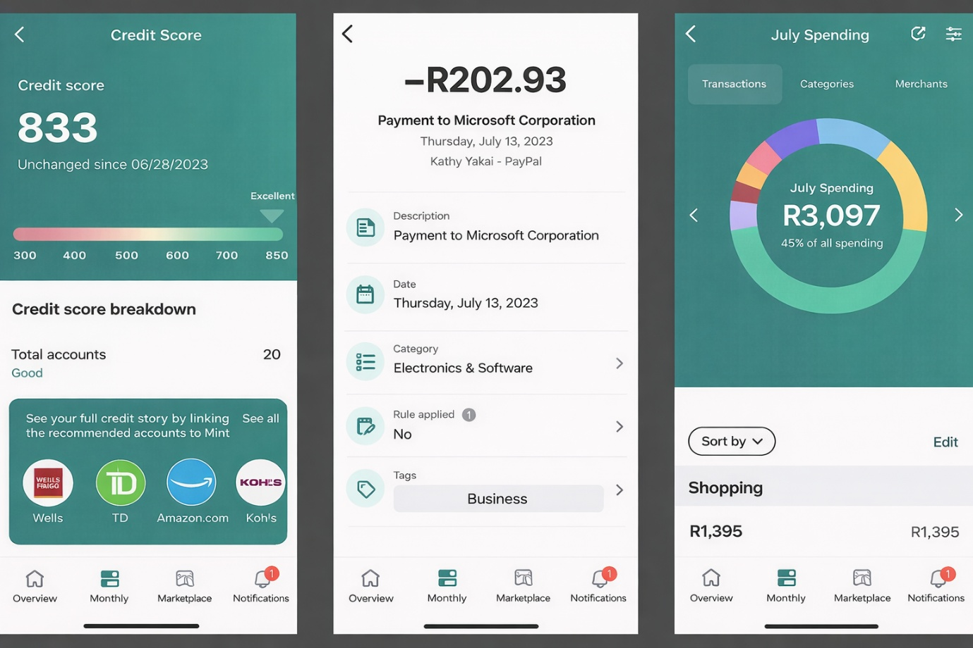
https://www.pcmag.com/reviews/mintcom
(screenshot taken from google images as I do not own an android mobile device) *

Strengths
One of the major strengths of Mint is its ability to automatically sync financial data from multiple accounts. This eliminates the need for manual data entry and makes financial tracking more convenient for users. Another strength is the app’s user-friendly interface. The dashboard presents financial information in a clear and organized manner, making it easy for users to understand their spending patterns.
Mint also provides useful financial insights and alerts. Users can receive notifications about upcoming bills, unusual spending, or when they are approaching their budget limits. These alerts help users stay aware of their financial habits.Additionally, Mint offers credit score tracking, which allows users to monitor their credit health and identify factors that may affect their credit rating.

Weaknesses
Although Mint has many useful features, it also has some disadvantages. One concern is privacy and security because users must connect their bank accounts to the app. Some people may not feel comfortable sharing their financial information with a third-party service.
Another disadvantage is that the free version contains advertisements and financial product suggestions, which some users may find distracting.
Mint also depends on bank account connections, and these do not work equally well in every country. As a result, users outside the United States may have limited access to some features.

Innovative Features
Mint includes several innovative features that make it a powerful budgeting tool. One notable feature is automatic expense categorization. The app uses algorithms to analyse transactions and place them into relevant spending categories automatically.
Another innovative feature is spending trend analysis. Mint generates charts and graphs that show users how their spending changes over time, allowing them to identify patterns and adjust their financial habits.
The app also provides personalized financial insights and suggestions based on user spending behaviour. These recommendations can help users reduce unnecessary expenses and improve their financial management.

2.2 YNAB (You Need A Budget)

Overview
YNAB (You Need A Budget) is a budgeting app that helps users take control of their money by planning how to use it. Instead of just tracking spending, it encourages users to give every amount of money a purpose. It uses a method called zero-based budgeting, where all income is divided into categories like rent, food, transport, and savings. This helps users avoid overspending and manage their money better. Users can enter transactions manually or link their bank accounts. The app then organizes spending into categories and shows how much money is available in each one.
YNAB also has a simple dashboard and includes lessons and guides to help users learn better budgeting habits.

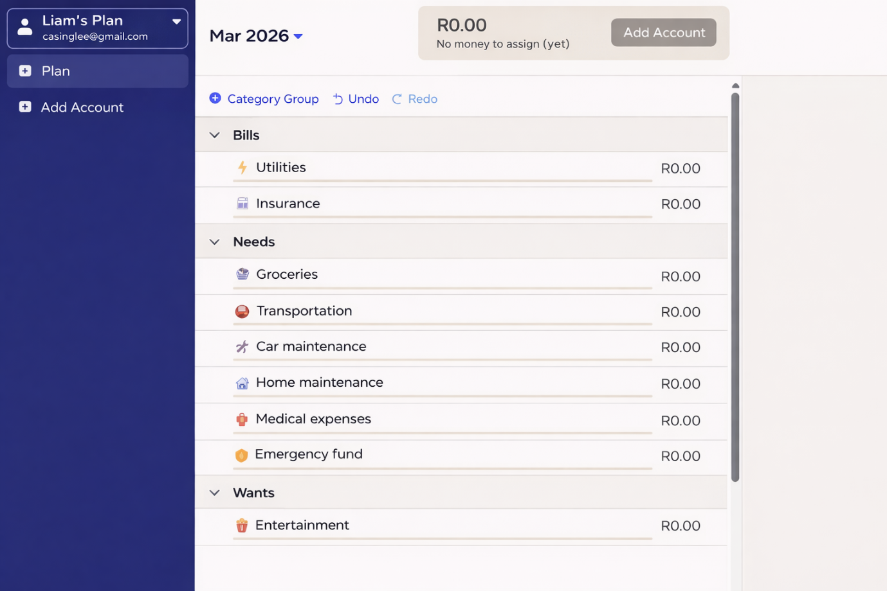Budget dashboard & Category based budget

Strengths
One of the biggest strengths of YNAB is its strong budgeting methodology. The zero-based budgeting approach encourages users to plan their spending carefully and ensures that every amount of money is assigned a purpose.
Another strength is the app’s focus on financial education. YNAB provides various tutorials, videos, and learning resources that teach users how to improve their financial habits and develop long-term budgeting skills.
The application also offers powerful budgeting tools that allow users to easily adjust their budgets when unexpected expenses occur. This flexibility helps users stay on track with their financial goals even when their financial situation changes. Additionally, YNAB provides detailed reports and visual graphs that help users understand their spending trends and evaluate their financial progress over time.

Weaknesses
Despite its powerful budgeting system, YNAB has several disadvantages. One of the most notable weaknesses is that the app requires a subscription fee to use most of its features. Unlike many budgeting apps that offer free versions, YNAB requires users to pay a monthly or annual subscription after a trial period.
Another challenge is the learning curve associated with the YNAB budgeting method. New users may initially find the system confusing because it requires them to actively manage and plan their budget rather than simply track spending automatically.
Additionally, some users may prefer more automated budgeting tools. Although YNAB does support bank synchronization, it still requires more manual involvement compared to other budgeting apps.

Innovative Features
YNAB offers several innovative features that make it unique compared to many other budgeting applications.
One of the most innovative aspects of the app is its zero-based budgeting system, which encourages users to allocate every portion of their income to a specific category. This approach helps users gain greater control over their finances and avoid unnecessary spending.
Another innovative feature is the app’s real-time budget adjustment system. When users overspend in a category, they are encouraged to move money from another category to cover the expense. This promotes flexibility and encourages responsible financial decision-making.
YNAB also provides goal tracking tools, allowing users to create financial goals such as saving for a vacation, paying off debt, or building an emergency fund. The app tracks progress toward these goals and provides visual feedback to motivate users.
Finally, the integration of educational resources within the app is another unique feature. By teaching users effective budgeting strategies, YNAB helps them build long-term financial management skills.

2.3 Wallet by BudgetBakers

Overview
Wallet by BudgetBakers is a personal finance management application designed to help users track their income, expenses, and financial goals in a simple and organized way. The app focuses on helping users gain a clear understanding of their financial situation through detailed tracking, visual reports, and budgeting tools.
Wallet allows users to manually record transactions or connect their bank accounts to automatically synchronize financial data. Once transactions are recorded, the app organizes them into categories such as food, transportation, entertainment, and bills. This categorization makes it easier for users to understand where their money is being spent. One of the key features of Wallet is its strong focus on financial planning. Users can create budgets for different categories and monitor their spending throughout the month. The app provides visual indicators that show how much of the budget has been used and how much money remains available.
The app also includes detailed charts, graphs, and reports that help users analyse their financial habits. These visualizations allow users to see patterns in their spending and make better financial decisions.
Another useful aspect of Wallet is its support for multiple currencies and shared accounts. This feature makes the app suitable for individuals who travel frequently or manage finances together with family members or partners.
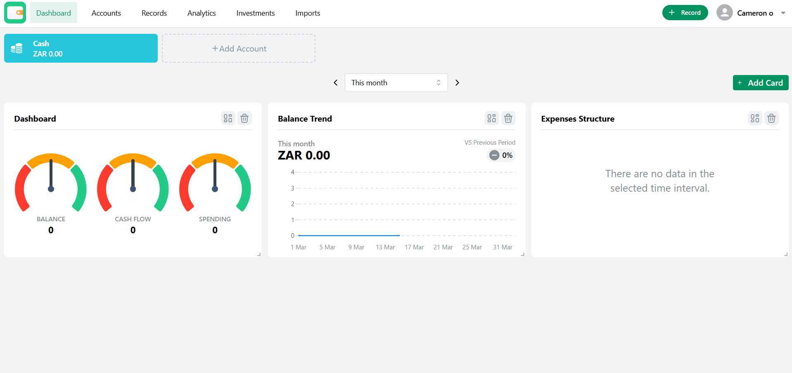Financial dashboard & expense tracking interface & spending reports and charts

Strengths
One of the main strengths of Wallet is its powerful financial reporting system. The app provides detailed graphs and charts that help users visualize their spending patterns and understand their financial behaviour.
Another strength is the flexibility the app offers in terms of budgeting. Users can create multiple budgets for different categories and adjust them based on their financial needs. The app also supports multiple currencies, which is useful for people who travel frequently or manage finances across different countries. This feature makes Wallet more versatile than many other budgeting apps. Additionally, Wallet supports shared accounts, allowing multiple users to track expenses together. This can be particularly useful for couples, families, or roommates who share financial responsibilities.

Weaknesses
Despite its useful features, Wallet also has some limitations. Some of the more advanced features are only available in the premium version of the app, which requires a paid subscription. This may limit access for users who prefer completely free budgeting tools.
Another weakness is that the interface can feel slightly complex for new users. Because the app includes many features and customization options, it may take some time for users to fully understand how to navigate and use the application effectively.
In addition, while bank synchronization is available, it may not support all banks in every country. This can reduce the effectiveness of automatic transaction tracking for some users.

Innovative Features
Wallet includes several innovative features that make it stand out among budgeting applications.
One notable feature is its advanced financial reporting system, which provides users with detailed visual charts and insights into their spending habits. These reports help users identify trends and make better financial decisions.
Another innovative feature is the shared account functionality, which allows multiple users to manage finances together. This is particularly useful for families, couples, or teams that need to track shared expenses.
Wallet also includes goal tracking tools, allowing users to set financial goals such as saving for a purchase or reducing expenses. The app tracks progress toward these goals and provides visual feedback to motivate users.
Finally, the app supports multi-currency tracking, which allows users to manage finances in different currencies. This feature is especially useful for travellers or people who work internationally.

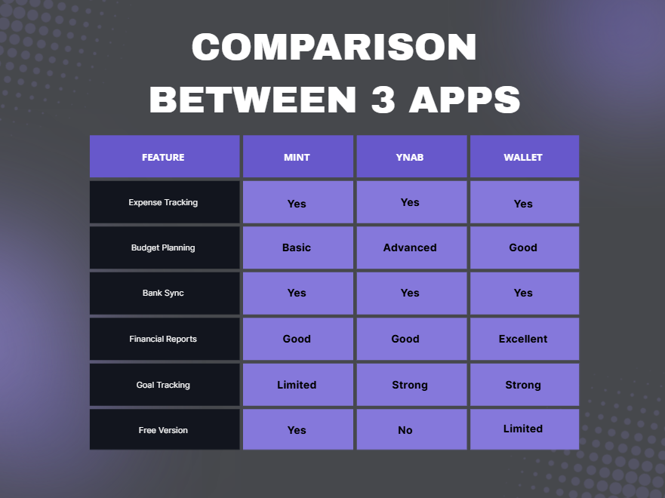

Best features to include in my app
After analysing the three applications, several useful features were identified that could be included in a new budgeting app. These features combine the strengths of each application to create a more effective financial management tool.
The most valuable features include:
- Automatic expense tracking
- Category-based budgeting
- Visual financial reports and graphs
- Goal tracking for savings
- Expense reminders and alerts
- Shared budgeting for families or couples
- Multi-currency support
- Spending insights and financial recommendations

Conclusion
The analysis of Mint, YNAB, and Wallet shows that budgeting applications can help users manage their money more effectively. Each application has useful features that support budgeting, expense tracking, and financial planning. Mint focuses on simplicity and automatic tracking, YNAB encourages planned spending and budgeting discipline, while Wallet provides detailed reports and flexible budgeting options.
The findings from this research will be used to guide the design of the proposed budgeting application. By combining the most useful features from these existing applications, the new system can provide a simple, user-friendly solution that helps users track expenses, manage budgets, and make better financial decisions.

References
- Mint App – Google Play Store
https://play.google.com/store/apps/details?id=com.cf_holding.mint.app&hl=en_ZA&pli=1

- YNAB Official Website
https://www.ynab.com/

- Wallet BudgetBakers Official Website
https://web.budgetbakers.com/dashboard

- Android Authority (budgeting app reviews)
https://www.androidauthority.com/

- Investopedia (budgeting tools information)
https://www.investopedia.com/

